**Return statement**

Return statement is used with for and function statements to **return** specific data from them, instead of return all statements as a one package.

**Note:**

* Statements that locate after return keyword will not executed as JS engine can reach to it.
* Return statement without value is an **undefined return** and it called **“void return”**

**Example:**

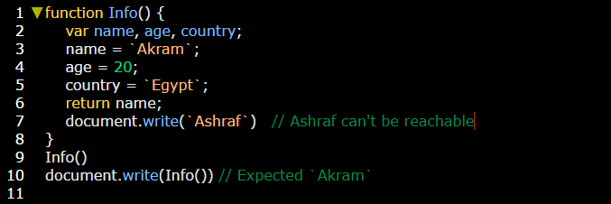

As usual you can make sure that statements located after return statement will not be executed by running this code in source tab:

